Project Report Template
Name: Liam White
Student ID: 106512828
Group Name: Late Bloomers
GitHub Repository Link: https://github.com/grageriann/Group-Project-Assignment
Jira Project Link: https://student-team-fnet57yj.atlassian.net/jira/software/projects/KAN/boards/2
Discord channel name for your group: wed-1430-g06

1. GitHub Contribution Summary

1.1 Commit History
- Branch Name: Main
- Total Number of Commits: 7
- Commit Frequency: every few days
- Screenshots of Commit Messages. Go to the GitHub Repository, click on “Commits”, select your name under users, take a screenshot/s and place it here
- 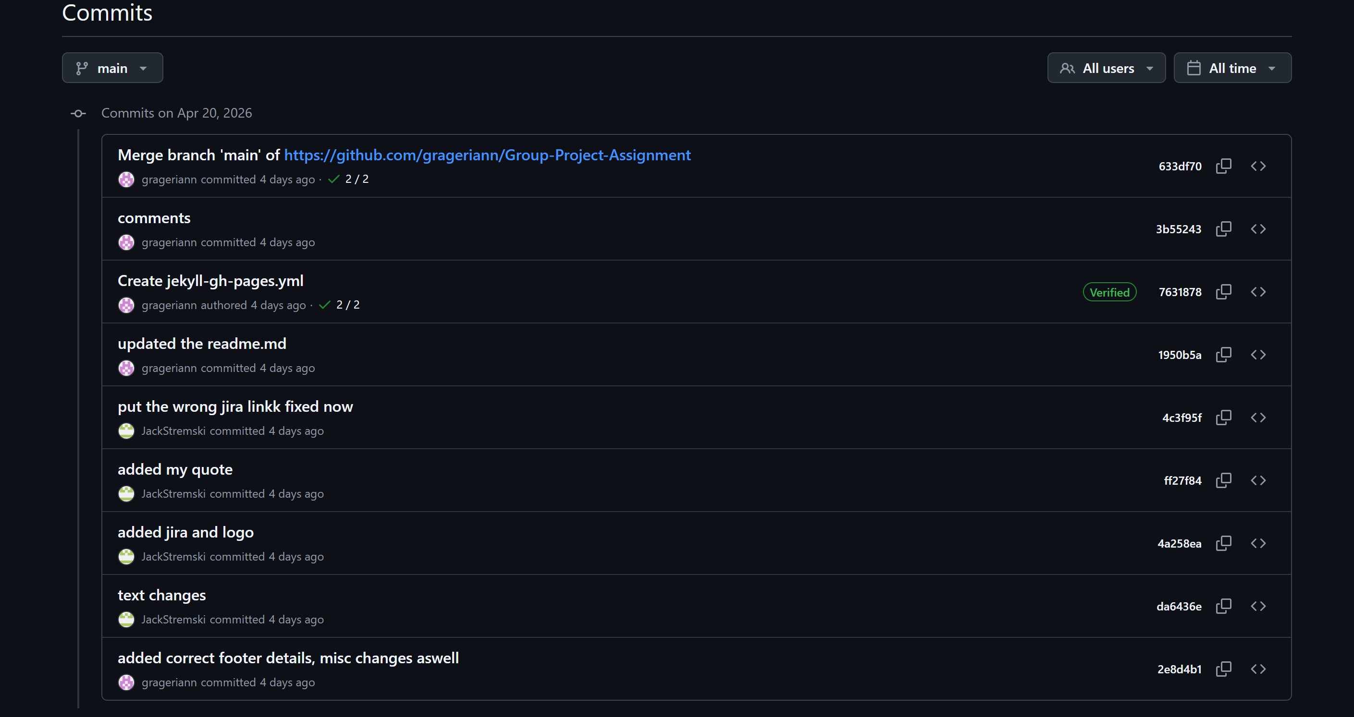
- 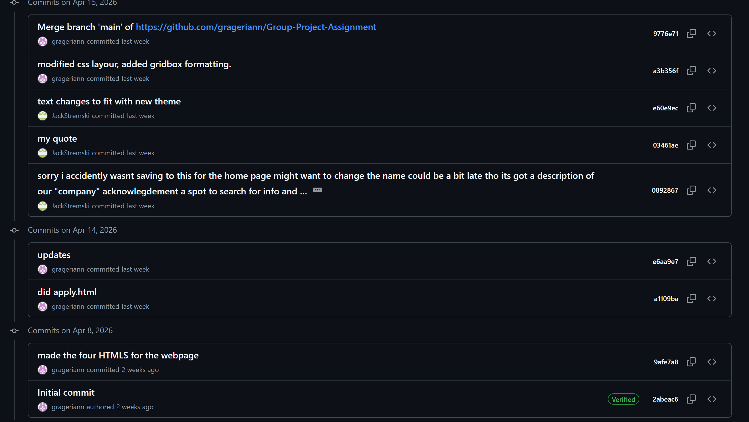

1.2 Contribution Breakdown
- Major Features or Sections Worked On:
  - [completed pages apply and about] – [created two pages, one for the purpose of applying for the job position and about the creators.]
  - [regex validation] – [made the regex validation for the apply page for the email, and also ensuring all fields are entered correctly.]

2. Discord Participation

2.1 Contribution Rating
Self-rating (1-5): [1 = Minimal, 5 = Highly Engaged] -4

2.2 Evidence of Participation
- Examples of Helpful Contributions:
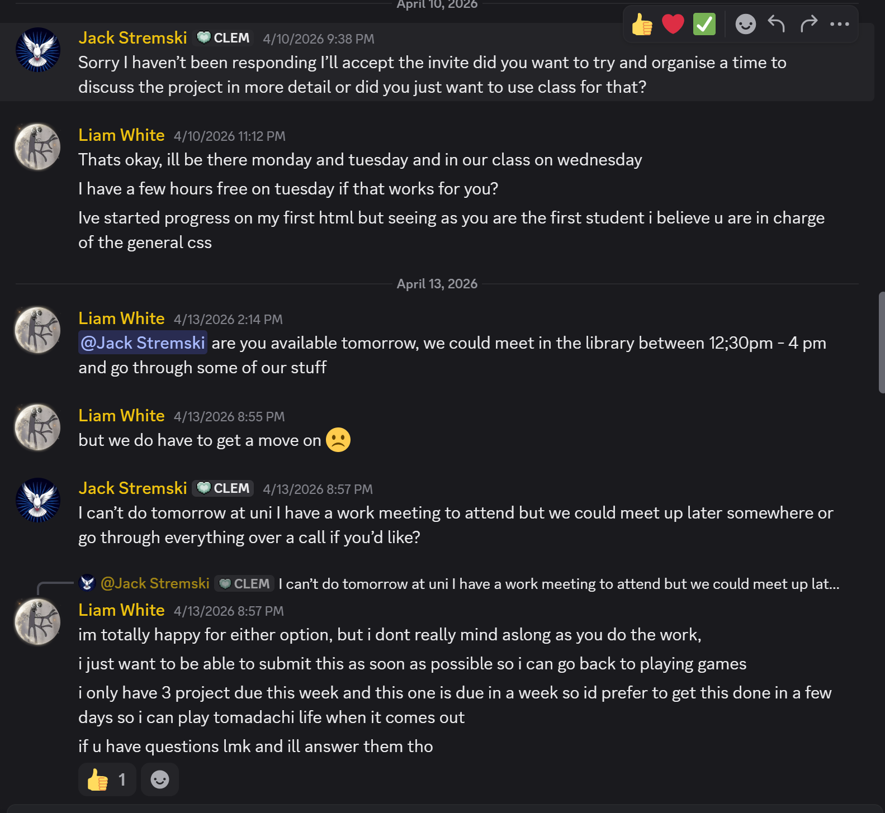
- Did I Seek or Offer Help? [Yes]
- If Yes, Describe an Example: I made sure to offer help for my partner incase he wanted to clarify or needed help with anything.

3. Final Project Assessment
- Did the final project meet my expectations? Why or why not? The website was fully functional and met the requirements of the task, however I wish we spent more time understanding the jira aspect of it,
- What was the strongest part of my contribution? I streamlined the page layout in css, making the general layout for the website.
- What did I do for improving the accessibility of our website? Making sure all text was visible and clear to read, aswell as being large enough and fit in the centre of the screen for the apply page was a big part of the accessibility, we also made sure to include the message to the traditional custodians of our land.

4. Reflection on Learning and Collaboration
- What did I learn from this project? I learnt to not rely on other people, as it can often times be risky
- What would I do differently next time? Make sure to meet with classmates before the assignment started to find like minded people who would want to finish the task early, so we didn’t have to rush to submit it.

